**Image Share**

**4/14/12**

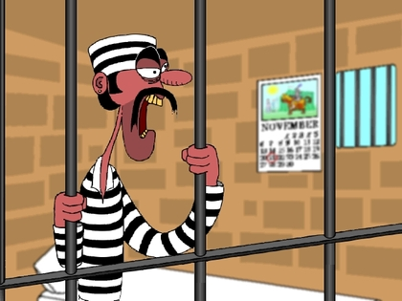

I chose this image because it represents Romeo and his predicament of being banished from Verona. Which is very similar to the figure above frustrated, and locked away in a cell with very little control of when he is getting out. Although Romeo is let free by the nurse shortly after his confinement, he was still “banished” from not only his city but his dear Juliet, which was entirely more frustrating then anything else. This images projects his anger and the devastating thoughts, of always being locked away, never being able to return to his old life.